
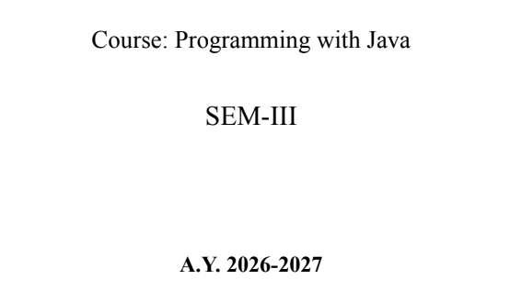
NAME: BHOOMI VIJAYVARGIYA
BATCH: A2
PRN: 25070122062

ASSIGNMENT No : 12
TITLE : Write a Java program to create and use user-defined packages.
Problem Statement: Write a Java program to create and use user-defined packages.
Learning Objectives: To create and use user-defined packages for organizing Java programs.
Theory:
Packages are used to organize related classes and interfaces into namespaces. User-defined packages improve code organization, reduce naming conflicts, and enhance reusability. They also support access protection and modular application development. Java packages simplify project management by grouping logically related components together. Large-scale software systems extensively use packages.
Code:
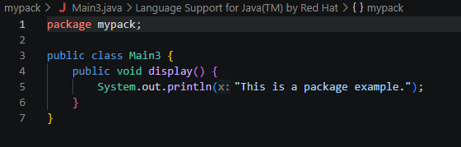
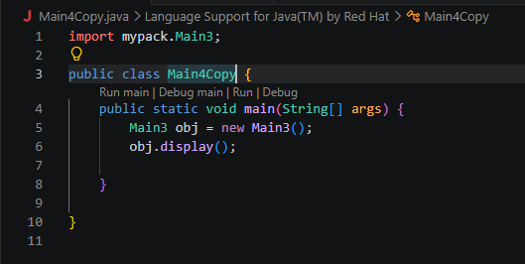
Output:
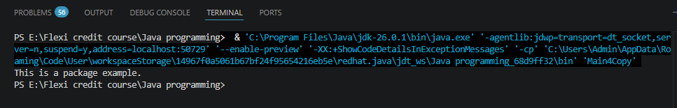
Outcome
Learned how to create, import, and use user-defined packages in Java to organize classes, improve code reusability, and manage programs efficiently.
Conclusion
User-defined packages help structure Java applications by grouping related classes, reducing naming conflicts, and making code easier to maintain and reuse.
Exercise
- Create a Java program by developing user-defined packages for a College Management System. Create separate packages for student and faculty details, and display their information using classes from these packages.
Code
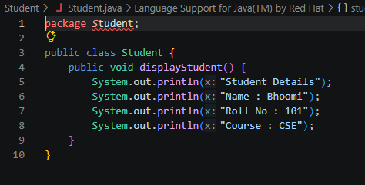
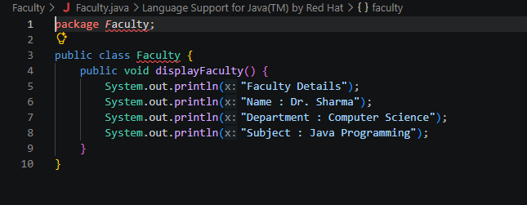
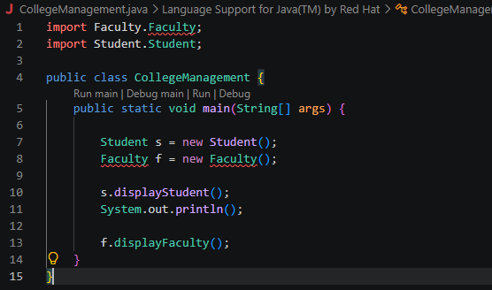
Output:
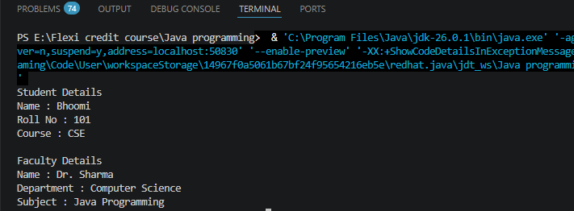
- Create a Java program by developing a user-defined package named library that contains a class to store and display book details such as book ID, title, author, and price. Import the package into the main program and display the book information.
Code:
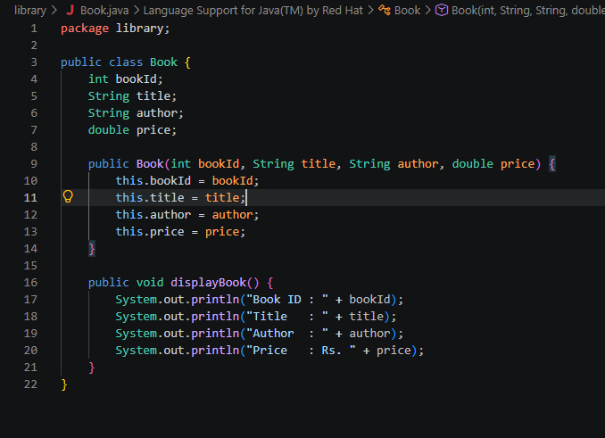
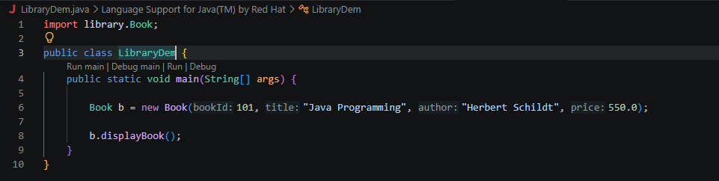
Output:
